 | University of Southern Queensland | Offline Version
 | USQ Safety Risk Management System
Note: This is the offline version of the Safety Risk Management System (SRMS) Risk Management Plan (RMP) and is only to be used for planning and drafting sessions, and when working in remote areas or on field activities. It must be transferred to the online SRMS at the first opportunity.

Safety Risk Management Plan – Offline Version
Assessment Title: |  |  |  |  |  | Assessment Date: |  | Click here to enter a date.
Workplace (Division/Faculty/Section): |  |  |  |  |  | Review Date:(5 Years Max) |  | Click here to enter a date.

Context
Description:
What is the task/event/purchase/project/procedure?
Why is it being conducted?
Where is it being conducted?
Course code (if applicable) |  |  |  |  | Chemical name (if applicable)
What other nominal conditions?
Personnel involved
Equipment
Environment
Other
Briefly explain the procedure/process

Assessment Team - who is conducting the assessment?
Assessor(s)
Others consulted:
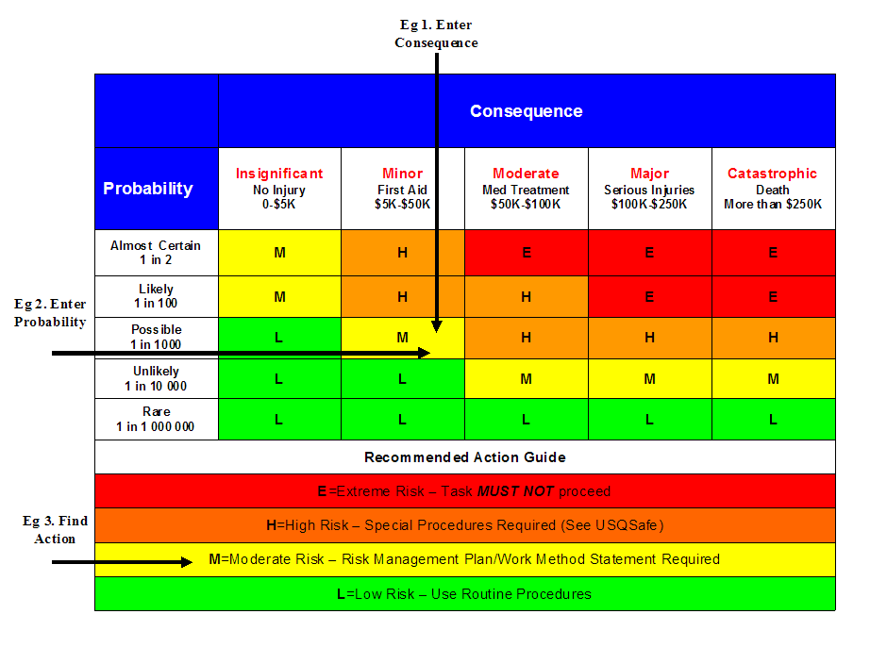

Step 1 (cont) | Step 2 | Step 2a | Step 2b | Step 3 |  |  | Step 4
Hazards:  From step 1 or more if identified | The Risk:  What can happen if exposed to the hazard without existing controls in place? | Consequence:  What is the harm that can be caused by the hazard without existing controls in place? | Existing Controls:  What are the existing controls that are already in place? | Risk Assessment:  Consequence x Probability = Risk Level |  |  | Additional controls:  Enter additional controls if required to reduce the risk level | Risk assessment with additional controls:
 |  |  |  | Probability | Risk Level | ALARP?  Yes/no |  | Consequence | Probability | Risk Level | ALARP?  Yes/no
Example
Working in temperatures over 35⁰ C | Heat stress/heat stroke/exhaustion leading to serious personal injury/death | catastrophic | Regular breaks, chilled water available, loose clothing, fatigue management policy. | possible | high | No | temporary shade shelters, essential tasks only, close supervision, buddy system | catastrophic | unlikely | mod | Yes
 |  | Select a consequence |  | Select a probability | Select a Risk Level | Yes or No |  | Select a consequence | Select a probability | Select a Risk Level | Yes or No
 |  | Select a consequence |  | Select a probability | Select a Risk Level | Yes or No |  | Select a consequence | Select a probability | Select a Risk Level | Yes or No
 |  | Select a consequence |  | Select a probability | Select a Risk Level | Yes or No |  | Select a consequence | Select a probability | Select a Risk Level | Yes or No
 |  | Select a consequence |  | Select a probability | Select a Risk Level | Yes or No |  | Select a consequence | Select a probability | Select a Risk Level | Yes or No
 |  | Select a consequence |  | Select a probability | Select a Risk Level | Yes or No |  | Select a consequence | Select a probability | Select a Risk Level | Yes or No
 |  | Select a consequence |  | Select a probability | Select a Risk Level | Yes or No |  | Select a consequence | Select a probability | Select a Risk Level | Yes or No
 |  | Select a consequence |  | Select a probability | Select a Risk Level | Yes or No |  | Select a consequence | Select a probability | Select a Risk Level | Yes or No
 |  | Select a consequence |  | Select a probability | Select a Risk Level | Yes or No |  | Select a consequence | Select a probability | Select a Risk Level | Yes or No
 |  | Select a consequence |  | Select a probability | Select a Risk Level | Yes or No |  | Select a consequence | Select a probability | Select a Risk Level | Yes or No
 |  | Select a consequence |  | Select a probability | Select a Risk Level | Yes or No |  | Select a consequence | Select a probability | Select a Risk Level | Yes or No
 |  | Select a consequence |  | Select a probability | Select a Risk Level | Yes or No |  | Select a consequence | Select a probability | Select a Risk Level | Yes or No
 |  | Select a consequence |  | Select a probability | Select a Risk Level | Yes or No |  | Select a consequence | Select a probability | Select a Risk Level | Yes or No
 |  | Select a consequence |  | Select a probability | Select a Risk Level | Yes or No |  | Select a consequence | Select a probability | Select a Risk Level | Yes or No
 |  |  |  | Select a probability | Select a Risk Level | Yes or No |  | Select a consequence | Select a probability | Select a Risk Level | Yes or No
 |  |  |  | Select a probability | Select a Risk Level | Yes or No |  | Select a consequence | Select a probability | Select a Risk Level | Yes or No
 |  |  |  | Select a probability | Select a Risk Level | Yes or No |  | Select a consequence | Select a probability | Select a Risk Level | Yes or No
 |  |  |  | Select a probability | Select a Risk Level | Yes or No |  | Select a consequence | Select a probability | Select a Risk Level | Yes or No
 |  |  |  | Select a probability | Select a Risk Level | Yes or No |  | Select a consequence | Select a probability | Select a Risk Level | Yes or No

Step 5 - Action Plan (for controls not already in place)
Additional controls: | Resources: | Persons responsible: | Proposed implementation date:
 |  |  | Click here to enter a date.
 |  |  | Click here to enter a date.
 |  |  | Click here to enter a date.
 |  |  | Click here to enter a date.
 |  |  | Click here to enter a date.
 |  |  | Click here to enter a date.
 |  |  | Click here to enter a date.
 |  |  | Click here to enter a date.
 |  |  | Click here to enter a date.
 |  |  | Click here to enter a date.
 |  |  | Click here to enter a date.
 |  |  | Click here to enter a date.

Step 6 - Approval
Drafter’s name: |  |  |  | Draft date: | Click here to enter a date.
Drafter’s comments:
Approver’s name: |  | Approver’s title/position:
Approver’s comments:
I am satisfied that the risks are as low as reasonably practicable and that the resources required will be provided.
Approver’s signature: |  |  |  | Approval date: | Click here to enter a date.

